**Market Segmentation in Insurance**

WHAT IS MARKET SEGMENTATION?

In marketing, market segmentation is the process of dividing a broad consumer or business market, normally consisting of existing and potential customers, into subgroups of consumers based on some type of shared characteristics.

Objective: This case requires developing a customer segmentation to give recommendations like saving plans, loans, wealth management, etc. on target customer groups.

Dataset

The sample Dataset summarizes the usage behavior of about 9000 active credit cardholders during the last 6 months. The file is at a customer level with 18 behavioral variables.

Variables of Dataset

Balance

Balance Frequency

Purchases

One-off Purchases

Installment Purchases

Cash Advance

Purchases Frequency

One-off Purchases Frequency

Purchases Installments Frequency

Cash Advance Frequency

Cash Advance TRX

Purchases TRX

Credit Limit

Payments

Minimum Payments

PRC Full payment

Tenure

Cluster

The sample Dataset summarizes the usage behavior of about 9000 active credit cardholders during the last 6 months. The file is at a customer level with 18 behavioral variables.

**DATA CLEANING AND PREPROCESSING**

Data Types of the columns: -

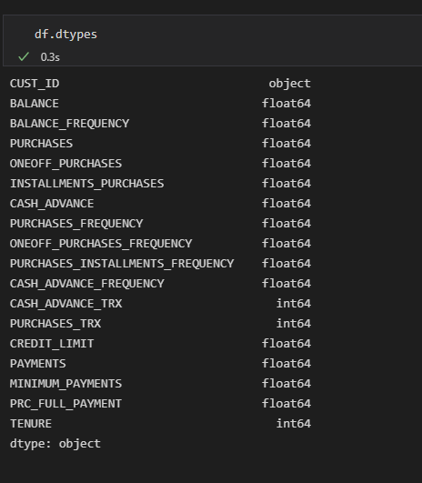

* CUST_ID column was dropped as it is nominal feature and string

Checking missing Values

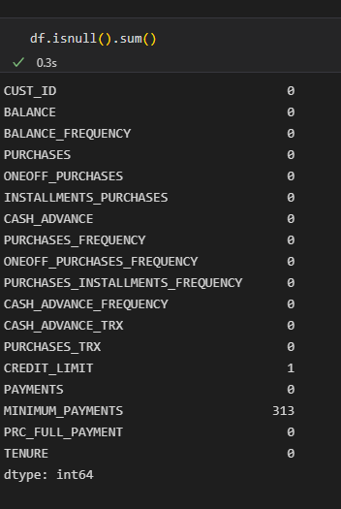

MINIMUM_PAYMENTS column and CREDIT_LIMIT columns had missing vales and replaced with mean of the respective variables.

Principal Component Analysis was performed for dimension reduction.

**MODELLING USING K-MEANS CLUSTERING**

Using Elbow method to determine the number of clusters in K-means clustering

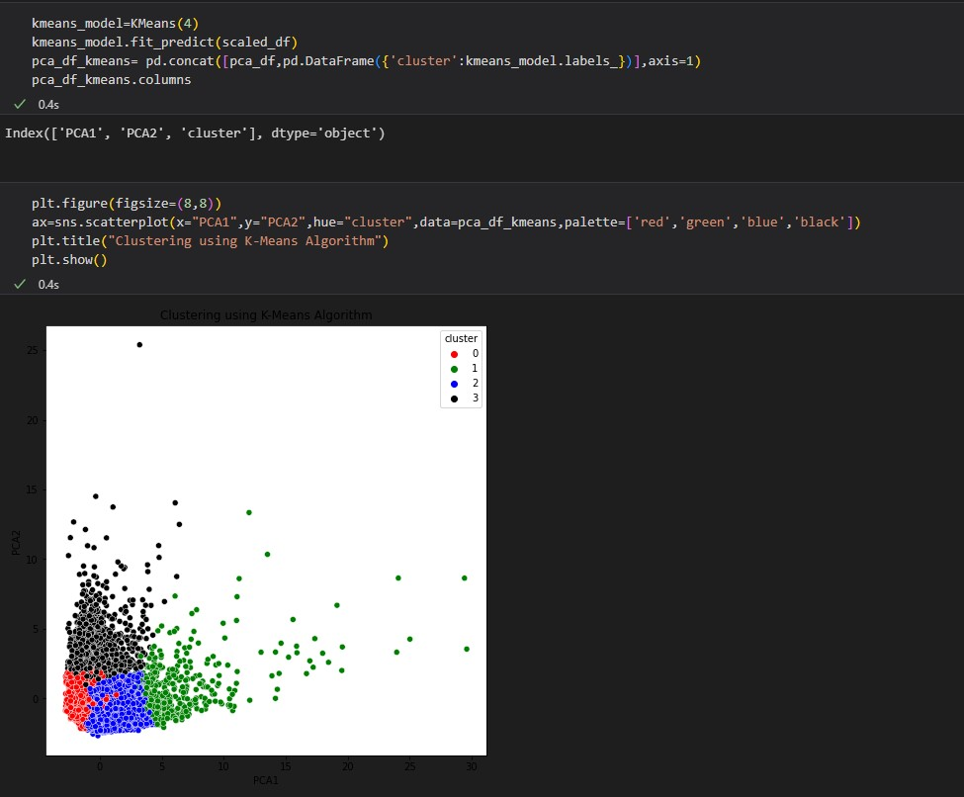

**DBSCAN Algorithm**

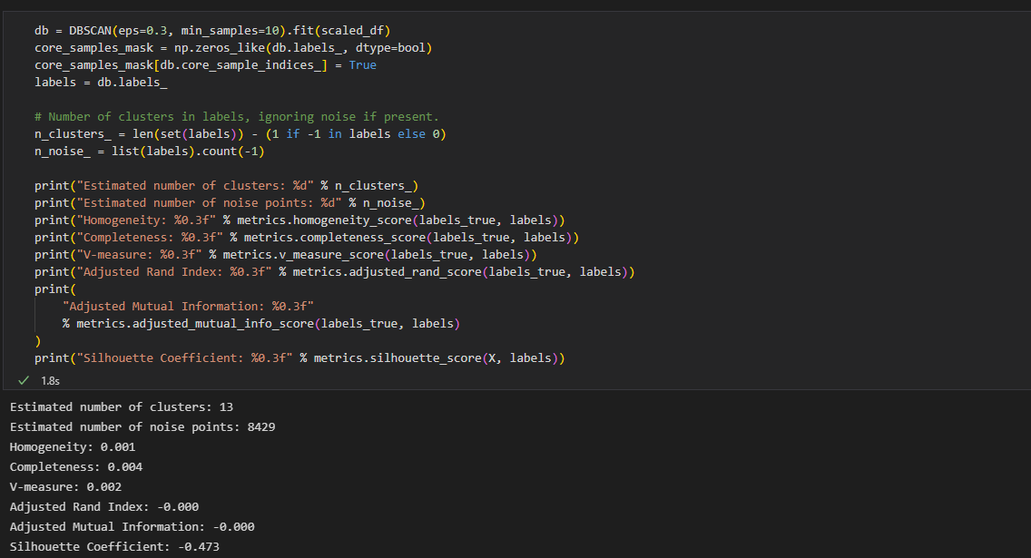

Result:- K-means clustering was chosen as the model for market segmentation.

Discussion:-

K-Means Clustering Algorithm has the following disadvantages-

* It requires to specify the number of clusters (k) in advance.
* It can not handle noisy data and outliers.
* It is not suitable to identify clusters with non-convex shapes.

Disadvantages of DBSCAN Algorithm

DBSCAN algorithm fails in case of varying density clusters.

Fails in case of neck type of dataset.

Does not work well in case of high dimensional data.

